**Systematic weaknesses in the evidence base for temperature-mediated phenological mismatch**

Jelmer M. Samplonius1, Angus Atkinson2, Christopher Hassall3, Stephen J. Thackeray4,  
Jakob J. Assmann5, Malcolm D. Burgess6,7, Jacob Johansson8, Katharine Keogan1,  
Kirsty Macphie1, James W. Pearce-Higgins9,10, Emily G. Simmonds11, Øystein Varpe 12,13, Jamie C. Weir1, Dylan Z. Childs14, Francis Daunt15, Tom Hart16, Owen T. Lewis16,  
Nathalie Pettorelli17, Ben C. Sheldon16, Albert B. Phillimore1

1 Institute for Evolutionary Biology, The University of Edinburgh, Edinburgh, UK  
2 Plymouth Marine Laboratory, Prospect Place, The Hoe, Plymouth, PL13DH, UK  
3 School of Biology, Faculty of Biological Sciences, University of Leeds, LS2 9JT  
4 Lake Ecosystems Group, UK Centre for Ecology & Hydrology, Library Avenue, Bailrigg, Lancaster, LA1 4AP, UK.  
5 Department of Biology, Aarhus University, Aarhus, Denmark  
6 RSPB Centre for Conservation Science, The Lodge, Sandy, Beds SG19 2DL  
7 Centre for Research in Animal Behaviour, University of Exeter, EX4 4QG  
8 Department of Biology, Department of Biology, Lund University, SE-22362 Lund, Sweden  
9 British Trust for Ornithology, Thetford, Norfolk, IP24 2PU, UK  
10 Conservation Science Group, Department of Zoology, University of Cambridge, David Attenborough Building, Pembroke Street, Cambridge, CB2 3QZ, UK  
11 Department of Mathematical Sciences and Centre for Biodiversity Dynamics, Norwegian University of Science and Technology (NTNU), Trondheim, Norway  
12 University of Bergen, Department of Biological Sciences, 5020 Bergen, Norway  
13 Norwegian Institute for Nature Research, 5006 Bergen, Norway  
14 Department of Animal and Plant Sciences, University of Sheffield, S10 2TN Sheffield, United Kingdom  
15 UK Centre for Ecology & Hydrology, Bush Estate, Penicuik EH26 0QB, UK  
16 Department of Zoology, University of Oxford, UK  
17 Institute of Zoology, Zoological Society of London, Regent's Park, London, United Kingdom

**Climate warming has caused the seasonal timing of many components of ecological food chains to advance** (Thackeray et al. 2010, 2016)**. Differential shifts lead to phenological asynchrony, often referred to as trophic mismatch when it is detrimental for consumers** (Cushing 1990)**. In the context of trophic interactions, it has been suggested that consumers will shift their phenology to adapt to shifts in the availability of their food source** (Visser and Both 2005)**, but they rarely do so in practice** (Thackeray et al. 2016; Kharouba et al. 2018)**. Whether such unequal shifts are detrimental or not is unresolved** (Johansson and Jonzén 2012; Reed et al. 2013*a*; Samplonius et al. 2016; Radchuk et al. 2019; Visser and Gienapp 2019)**. At present there has been no consistent analysis of the links between temperature change, phenological asynchrony, and individual-to-population level impacts across taxa, trophic levels and biomes at a global scale. Instead, many of our insights into mismatch and its impacts stem from a handful of independent single-system studies, varying greatly in their conceptual basis and methodological approach. Here, we propose five criteria that all need to be met to demonstrate that temperature-mediated trophic mismatch poses a growing risk to consumers. These criteria are: 1) an ephemeral resource contributes a large proportion of the consumer’s diet; 2) asynchrony between phenology of consumer and resource is increasing over time; 3) interannual variation in asynchrony is driven by interannual variation in temperature; 4) asynchrony reduces consumer fitness, 5) mismatch impacts negatively on consumer population size or growth. We conduct a literature review of 109 papers studying 132 taxa, and find that for most taxa only two of the five criteria are met. Moreover, all five criteria are only assessed for two taxa. The most commonly-tested criteria are 1 and 2, and few studies further examined evidence for criteria 4 or 5. Furthermore, effects of mismatch are heavily skewed towards juvenile stages rather than adults. Crucially, nearly every study was conducted in Europe or North America, and most studies were on terrestrial secondary consumers. We thus lack a robust evidence base from which to draw general conclusions about the risk that climate-mediated trophic mismatch may pose to populations worldwide.**

The shifting seasonal timing of key life history events, such as the budburst of trees, emergence of insects and migration and breeding times of vertebrates, is one of the three universal ecological responses to climate change (Walther et al. 2002; Parmesan and Yohe 2003). Such shifts in phenology have provided some of the earliest and strongest evidence that rising temperatures have left a discernible biotic imprint on the planet’s ecosystems (Visser et al. 1998; Parmesan 2006; Thackeray et al. 2016; Cohen et al. 2018). For many consumer species, phenological events are timed to coincide with peak abundance of a predictable food resource. However, the strength and direction of the phenological response to temperature frequently differs among species occupying different trophic levels, leading to asynchrony between resource and consumer (see box 1 for glossary). The consequences of such asynchrony were first studied in the early 1900s in the context of trophic interactions between fish larvae and their zooplankton resource: the match/mismatch hypothesis (reviewed by Cushing 1990). Fish larvae were found to spawn at a relatively fixed date, but zooplankton phenology was more variable across years, causing annual variation in mismatch between consumer and resource. The degree of mismatch was proposed to account for annual fluctuations in fish recruitment to the population (Cushing 1990). In recent years, the hypothesis that changing temperatures might increase the frequency of costly trophic mismatches between consumers and their resources has been widely discussed (Visser and Both 2005; Durant et al. 2007; Renner and Zohner 2018; Visser and Gienapp 2019). The impact of mismatched phenological interactions on the fates of consumer species was identified as a key uncertainty in the fifth assessment report of the IPCC (IPCC 2014).

**Box 1: Glossary of terms widely used in the study of trophic mismatch**

**Phenology:** the study ofcyclically recurring biological events, such as the seasonal timing of tree leafing, insect hatching, or animal reproduction. In this work, we also use it to refer to the events themselves, as has become the norm in the literature.

**Trophic level:** the position that an organism occupies in the food chain. Primary consumers are herbivores (e.g. winter moth, caribou), and secondary consumers are omnivores or carnivores (e.g. great tit, herring)

**Phenological sensitivity:** the extent to which phenology responds to biotic or abiotic variables, for example an advance in breeding in response to temperature.

**Phenological/trophic asynchrony:** when the peak consumer demand does not coincide with the peak availability of the resource.

**Phenological/trophic mismatch:** often used interchangeably with phenological/trophic asynchrony, although here we will use the original definition, referring to mismatch when asynchrony is detrimental to the consumer. The latter can also be referred to as mistiming.

Asynchrony and phenological mismatch are often used interchangeably in the ecological literature, but we suggest that these terms are conceptually different (Johansson et al. 2015). Mismatch implies a cost to the consumer (Cushing 1990), whereas trophic asynchrony only implies that trophic levels have different timings (Visser and Both 2005; Both et al. 2009). We note that mismatch is normally conceptualised from a one-way, bottom-up perspective (i.e. asynchrony leading to detrimental effects on consumers), rather than potential top-down effects upon prey and resources (but see Deacy et al. 2017). Asynchrony has been detected in many study systems (Thackeray et al. 2010, 2016; Kharouba et al. 2018), but to demonstrate negative consequences of asynchrony on the consumer (i.e. mismatch), a certain number of conditions need to be met. For mismatch to be identified as detrimental, the consumer must depend on a short, seasonally-pulsed or ephemeral resource (Willson and Womble 2006; Dunn et al. 2011; Reneerkens et al. 2016; Samplonius et al. 2016; Mallord et al. 2017; Youngflesh et al. 2017), and there should be negative effects of mismatch on consumer fitness (Vatka et al. 2011; Reed et al. 2013*b*, 2013*a*; van Asch et al. 2013; Gienapp et al. 2014; Ramakers et al. 2019*a*). Ultimately, the main concern is that, when sufficient individuals in a population become mismatched, it affects mean demographic parameters across that population, leading to population declines (Winder and Schindler 2004; Both et al. 2006; Miller-Rushing et al. 2010; Plard et al. 2014; Visser and Gienapp 2019). Despite the identification of these conditions for mismatch to occur, we currently lack knowledge about how well-studied they are across taxa, and how often mismatch leads to population declines.

**Five criteria for demonstrating mismatch**

Here, based on ideas that have been widely discussed in the literature and which we outline above, we propose five criteria that must all be met for temperature-mediated mismatch to be both present, and causing population declines (Table 1): (1)  the consumer is highly reliant on a seasonally ephemeral resource; (2) the degree of asynchrony between consumer and resource phenology is increasing; (3) the degree of asynchrony is temperature sensitive; (4) asynchrony impacts negatively on consumer fitness (mismatch), and (5) mismatch impacts negatively on population growth (Miller-Rushing et al. 2010). In Table 1 we identify some of the methods that can be used to test each of these criteria. In the next section we summarise the existing biological evidence for these criteria, with a particular focus on general insights that have emerged from multi-species studies and formal meta-analyses on questions that are pertinent to the study of mismatch.

*Evidence for phenological asynchrony*

Large-scale comparative analyses of phenological responses and formal meta-analyses provide ample evidence that on average spring timings are advancing at mid-high latitudes, and that species vary in their response to temperature (Edwards and Richardson 2004; Thackeray et al. 2010; Cohen et al. 2018). In two large multi-species analyses based on phenological data from the UK, the phenology of secondary consumers advanced less than primary producers and consumers over time (Thackeray et al. 2010, criterion 2) and in response to temperature (Thackeray et al. 2016, criterion 3). For marine taxa, the magnitude of phenological advance varied among trophic groups, with phytoplankton, zooplankton and bony fish all more responsive than seabirds (Poloczanska et al. 2013; Keogan et al. 2018). However, while multi-species and multi-population studies provide valuable insights into general trends and patterns of inter- and intra-specific variation in phenological responses, they do not estimate *in situ* responses for specific trophic interactions. Of those studies that focus on trophic interactions known to be important to the consumer for a short period (criterion 1) most focus on a single interaction. Such studies have reported increasing asynchrony over time (criterion 2), e.g. in great tits *Parus major* and winter moth *Operophtera brumata* (Visser et al. 1998; Visser and Holleman 2001). However, a recent analysis of the phenological time series underpinning 27 species interactions (including but not limited to trophic interactions) found that whilst the degree of asynchrony has changed over time, the number of cases where asynchrony had increased was roughly balanced by the number of cases where asynchrony had decreased (Kharouba et al. 2018). The same study also found that whilst phenology was sensitive to temperature in the ecological systems considered, it was not possible to attribute temporal trends in asynchrony to long-term increases in temperature (criterion 3).

*Potential consequences of trophic mismatch*

The most prominent evidence that phenological asynchrony actually results in mismatch (criterion 4) comes from intensively-studied wild systems, such as that of the reliance of great titson winter moth caterpillars to feed their young. For these birds, asynchrony between the timing of peak nestling demand and peak caterpillar biomass has negative consequences for individual fitness and annual mean fitness (Reed et al. 2013*a*, 2013*b*). Meta-analyses of selection estimates in the wild report consistent selection pressures for earlier phenology (Kingsolver et al. 2012; Radchuk et al. 2019), but directional selection has not become stronger over time (Radchuk et al. 2019). However, meta-analyses addressing selection on phenology consider only absolute timing rather than relative timing of a consumer with respect to a resource (Visser and Both 2005), so it is not always clear to what extent phenologies are converging or diverging over time. Furthermore, to date there has been no meta-analysis of fitness consequences of mismatch.

Trophic asynchrony is of conservation concern if it impacts negatively on population size (criterion 5). Two long-term study of great tits found no evidence that asynchrony impacts negatively on population size (Reed et al. 2013*a*; Vedder et al. 2013), whereas a study of several populations of pied flycatchers *Ficedula hypoleuca* in the Netherlands reported stronger population declines with earlier caterpillar phenology (Both et al. 2006). The only multi-species studies on this theme that we are aware of are for birds, one from across Europe (Both et al. 2010) and one in the UK (Franks et al. 2018). Both et al. (2010) found that long distance migrant passerine birds in European forest habitats had declined more than species that migrated less far or species inhabiting marsh habitats, which the authors attributed to the migrants becoming mismatched in the forest habitats with their more ephemeral resource peak. Franks et al. (2018) found that, across 21 UK bird species, population declines were more pronounced for species that had advanced their breeding phenology least. These population declines were attributed to an increase in mismatch, but no data was presented of the underlying trophic level, making such conclusions speculative.

Table 1. Sequential criteria of evidence that climate change induced mismatch is increasing and a cause for concern, with a consideration of the data and methods that can be used.

|  |  |  |
| --- | --- | --- |
| Criterion | Evidence required | Data and Methods |
| 1. An ephemeral resource contributes a large proportion of the consumer’s diet | A large proportion of the diet is composed of a species or food type that shows a pulsed seasonal distribution | A variety of methods for quantifying diet composition exist, including direct observation of feeding, gut content dissection, faecal/regurgitate dissection, metabarcoding and stable isotope analysis. Requires that relevant aspects (e.g., biomass, abundance) of the favoured resource are measured over time within at least one season and analysis reveals a pulsed intra-year relationship. In the average year the period of high resource availability should be shorter than the period of peak demand |
| 2. Asynchrony between consumer and resource phenology is increasing over time | Analysis of time-series of consumer and resource phenology, with a test of whether trends in timing  differ and whether this leads to an increase or decrease in asynchrony | Requires a time series that covers a period of temperature change. A large number of phenological time series exist, as recorded by researchers, citizens, herbaria, etc. Statistical analysis of increasing asynchrony is easily achieved by including an interaction between year and species. Inference of whether asynchrony is increasing or decreasing requires inspection of predictions based on estimated elevations and slopes of the modelled relationships for each species |
| 3. Variation in asynchrony is driven by interannual variation in temperature | Identification of the time period(s) over which consumer and resource is sensitive to temperature. Evidence that temperature is the driver | A variety of methods exist for identifying the time period over which phenology of each species is sensitive to temperature (Bailey and De Pol 2016; Teller et al. 2016; van de Pol et al. 2016; Simmonds et al. 2019*a*). Confidence in attribution can be increased by experiments or by including year as a term in the model (Keogan et al. 2018), thereby de-trending the phenology data (Iler et al. 2017). Estimating temporal trends in temperature variables is also worthwhile, as differing trends may generate asynchrony (Visser et al. 2003; Both et al. 2004). |
| 4. Asynchrony impacts negatively on consumer fitness: mismatch | A suitable measure of consumer fitness decreases with increasing asynchrony | Can be assessed within years (relative fitness) or among years (mean fitness) or both (Reed et al. 2013*a*, 2013*b*). Depending on how asynchrony varies across individuals or years, the relationship between fitness and asynchrony may be a linear decline or a humped relationship. If the former, care may need to be taken to establish causation (Verhulst and Nilsson 2008). Ideally, models should take into account both asynchrony with peak resource and phenological distribution of the resource (Durant et al. 2005; Ramakers et al. 2019*b*). Studies of impacts on relative fitness are informative regarding selection and opportunities for adaptation, whereas studies on mean fitness may be informative regarding demographic rates (Visser and Gienapp 2019) |
| 5. Mismatch impacts negatively on consumer (meta) population size or growth | Negative effects of asynchrony on fitness (4) that have a negative effect on population size/growth, as assessed over multiple years | Requires long-term data on mismatch and population size. The impact of mismatch on demographic rates can be incorporated into a population model (Simmonds et al. 2019*b*) or the causal pathways between mismatch and population growth can be assessed in a structural equation model (Mclean et al. 2016). It is important to rule out a causal effect of other variables (e.g., land-use, resource availability, sea ice, population density) that have changed over time (Youngflesh et al. 2017). Such confounding effects can partially be accounted for by including year as a term to detrend the analysis (Iler et al. 2017; Keogan et al. 2018) |
|  |  |  |

**Literature survey**

We conducted a broad survey of published work on trophic mismatch across terrestrial, marine and freshwater systems with the aim of: (i) examining the evidence that temperature-mediated trophic mismatch is increasing and impacting negatively on consumer species and (ii) identifying gaps in the evidence base, thereby allowing us to (iii) make recommendations for priority areas for future work. To this end, we extracted data from published, peer-reviewed original research in which a trophic interaction was studied in relation to any of the five criteria we proposed as vital to the study of trophic mismatch (Table 1). Only original studies, where the specific interaction between consumer and resource could clearly be identified were included (see appendix A for methodological details).

*Taxonomic and geographical bias in the data*

The search identified 772 papers, for 12 of which the full text could not be found, 571 of which were not relevant, and 80 of which had no extractable data, resulting in a total of 109 papers that had relevant data on 132 consumer taxa (Fig. S2). The characteristics of each study can be found in supplementary information (Table S1).

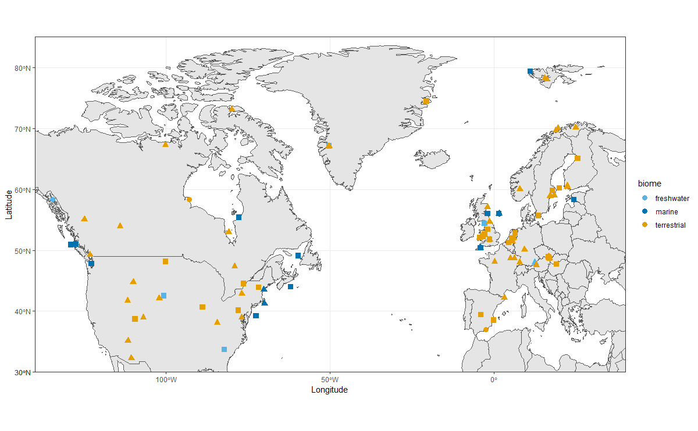

Figure 1. Locations of all but six studies found for all taxa, subdivided by biome (colour) and consumer trophic level (triangles = primary, squares = secondary, circles = >secondary). Not shown are a study in Siberia, two in China, two in Japan, and one in Antarctica.

All but eight of the 132 trophic interaction studies were in Europe or North America (Fig. 1). Terrestrial interactions comprised 81.5% of the data, with marine (14%) and freshwater interactions (4.5%) much scarcer. For most interactions the consumer was a secondary consumer (58%), with studies of primary (36.5%) or higher than secondary (5.5%) consumers less common. Birds made up the majority of the consumer taxa studied (53%), while 29.5% of taxa were insects, 8% were fish, 5% were mammals and 4% were crustaceans.

*Testing the five criteria*

The most tested criterion was criterion 1 (97% of interactions, n=128/132) - relating to dependence on an ephemeral resource (Fig. 2, top panels). However, rather than conducting direct tests on the seasonal distribution of resources, 72% (n=92/128) of these included only a statement based on *a priori* knowledge of the natural history of the system that the resource was both ephemeral and important to the consumer. Excluding the cases where criterion 1 was not explicitly tested, criterion 2 was the most frequently tested (72% of interactions, n=95/132), relating to whether phenological asynchrony was increasing over time (Fig. 2, top panels). The remaining criteria were all tested substantially less frequently, with criterion 5 (population consequences) being the least often tested (7.6% of interactions, n=10/132). Surprisingly few studies report data for criterion 3 (Fig. 2, top panels), which relates temperature to mismatch, and this was almost never reported for marine and freshwater taxa. The distributions of criteria tested were broadly similar across consumer levels and biomes, with the exception of primary consumers for which criteria 3 and 4 appear slightly more common.

Our analysis could identify only two out of 132 consumer taxa for which all five trophic mismatch criteria have been tested at least once: both of these are forest-breeding passerine birds studied in Europe - the great tit and the pied flycatcher. In a further 13 taxa, four out of five criteria were assessed. In the remaining 117 taxa, three or fewer criteria were studied, with the majority (58%, n=77/132) of consumer taxa having only two of the five criteria known (Fig. 2, bottom panels). Breaking this same analysis down to the per study level, no single study explicitly tests all five criteria (Fig. S3). This is generally due to a tendency for studies to focus on either phenology slopes, or the consequences of asynchrony. Only a handful of studies detail temporal slopes, temperature slopes, and consequences of asynchrony in one study (Visser et al. 2006; Atkinson et al. 2015; Ross et al. 2017).

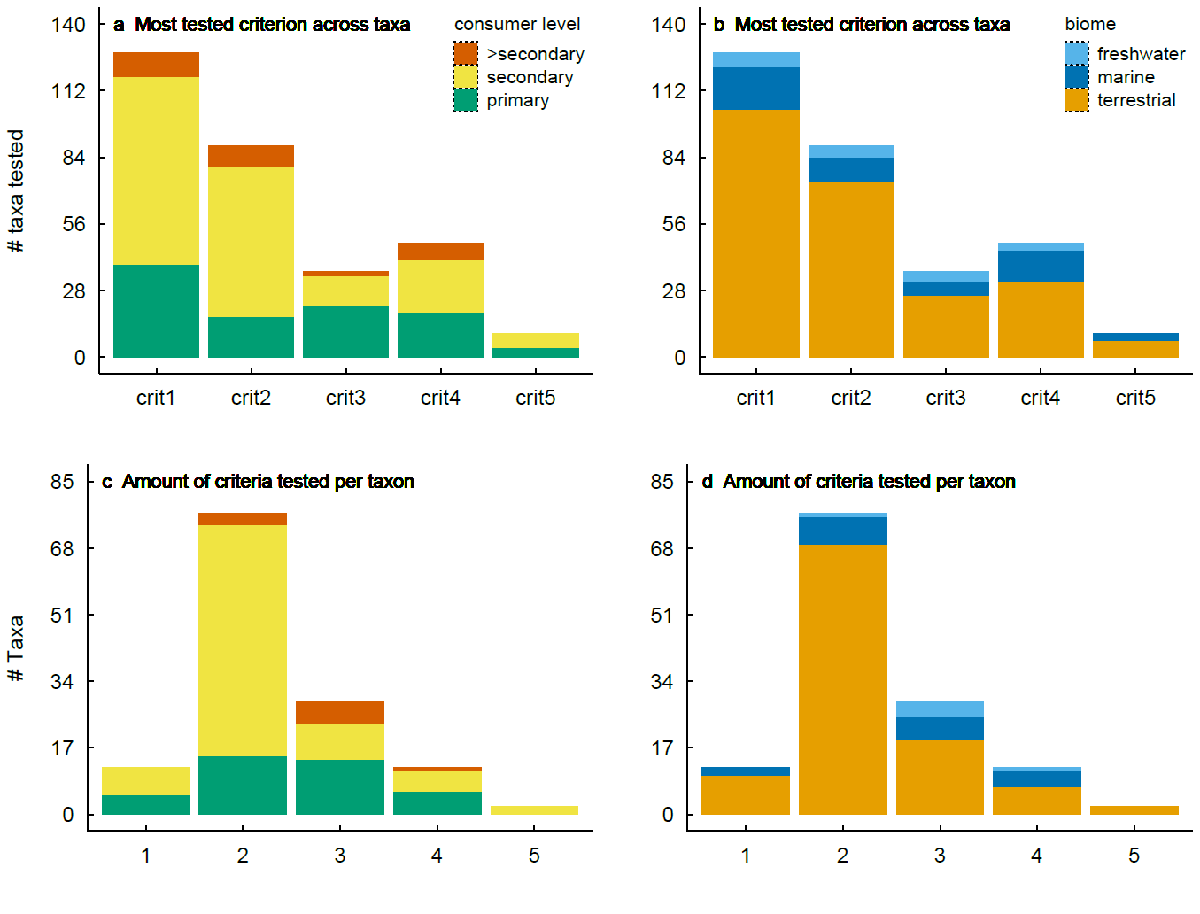Figure 2. The most tested criterion (table 1) across taxa (a, b), and how many criteria were tested per taxon (c, d). The left panels (a, c) are divided by trophic level, and the right panels by biome (b, d).

*Phenology slopes over time and temperature*

Consumers showed a marginal tendency to advance their phenology by less than their resource (Fig. 3). In 61% (n=58/95) of the cases, the phenology slope over time was greater for the resource than for the consumer (Fig 3a,b). For the phenological response to temperature, the consumer slope was greater than the resource slope in 59% (n=13/22) of cases (Fig 3c,d). The degree to which these patterns differ across biomes and trophic levels is not testable with this dataset, since the number of slope estimates is too low for non-terrestrial and non-secondary consumers. Based on visual inspection, it appears that especially terrestrial secondary consumers tend to be slower-advancing than their resource. However, more data on underrepresented groups would be required to reach general conclusions about these patterns.

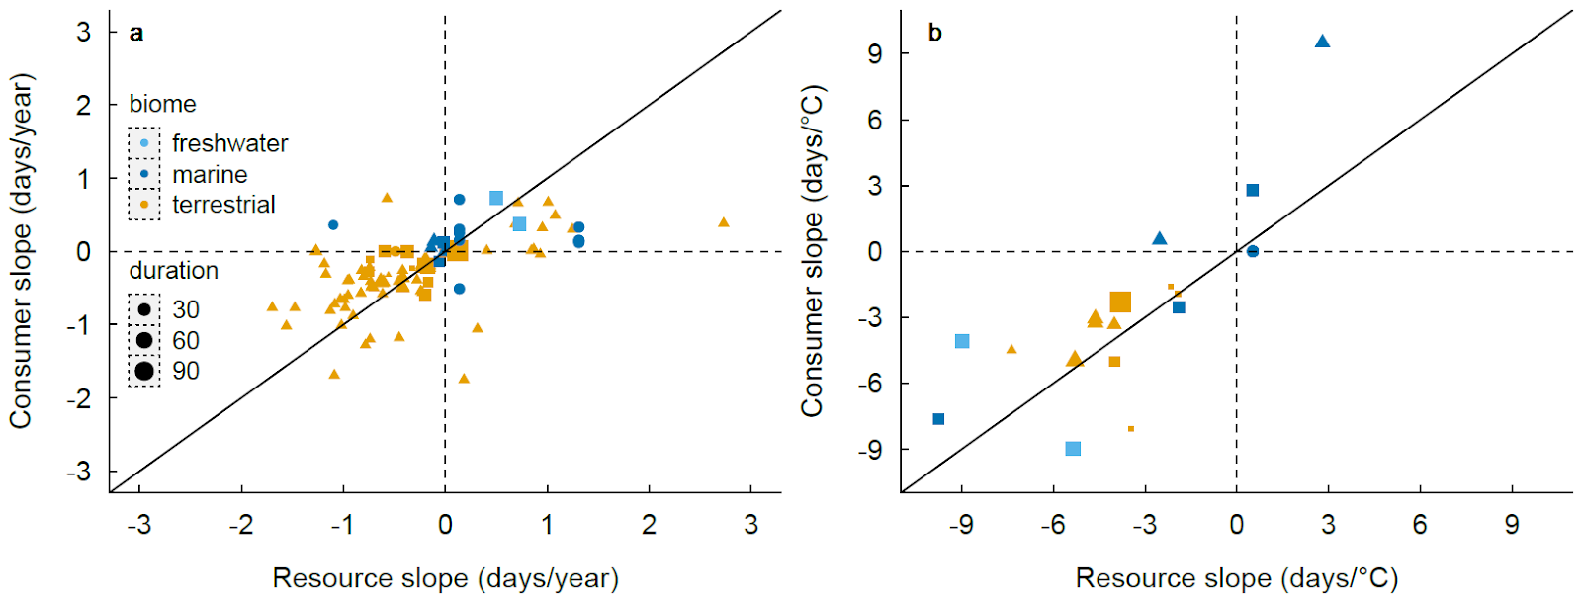

Figure 3. Consumer versus resource slopes in relation to year and temperature. Symbol shapes represent consumer trophic level (triangles = primary, squares = secondary, circles = >secondary), and larger symbols are from longer time series. The diagonal line represents an equal rate of change by consumer and resource. Points above the line represent systems where resource phenology is advancing more rapidly than that of the consumer, whereas points below the line represent systems where consumer phenology is advancing more rapidly than resource phenology.

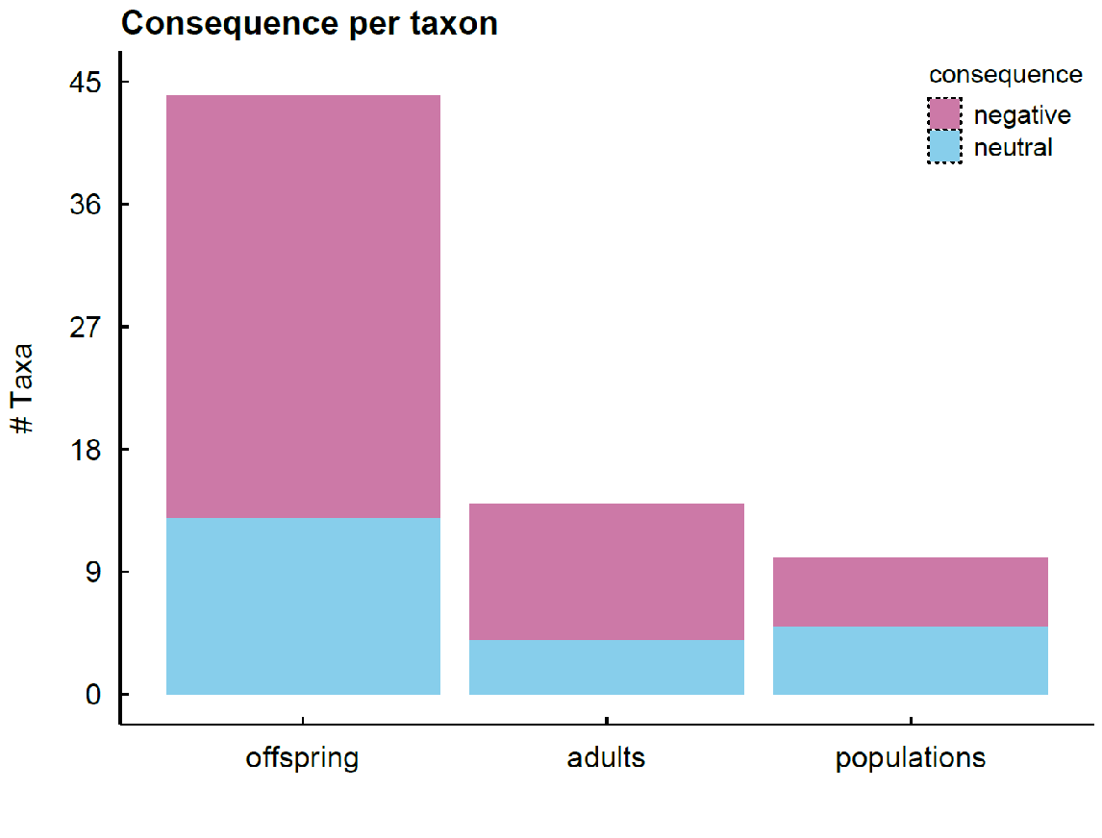

Figure 4. Number of taxa in which consequences of trophic mismatch were studied, divided into those where the effect reported was negative or neutral. Studies tend to focus on the effects on offspring rather than adult and population consequences.

Fitness consequences in relation to trophic mismatch (criterion 4) are studied in 36% (48/132) of the consumers (Fig. 2, top panels). Consequences of asynchrony for offspring are studied about three times as often as consequences for adults (Fig. 4), though it is possible that this reflects a research bias to study demographic rates that are more sensitive to mismatch. In about a third of the taxa, no negative effect of asynchrony on fitness was reported (Fig. 4). By far the least studied consequence of trophic asynchrony is its effects on population growth (criterion 5, Fig. 2, 4). In half of these interactions (n =5/10), there was no effect of asynchrony on population growth.

**Implications and recommendations**

Our survey reveals a lack of robust evidence from which to draw general inferences about temperature-mediated trophic mismatch. Specifically, the full causal chain from temperature change, to temperature-driven shifts in seasonal timing, consumer-resource synchrony, and individual-to-population level impact has rarely been studied. Only two out of 132 taxa studied all criteria, and for the majority of study systems, only one or two out of five criteria needed to demonstrate mismatch were met. The available studies were strongly biased toward terrestrial secondary consumers (especially birds) in the Northern Hemisphere (largely Europe and North America). Notably, the effects of climate warming on trophic asynchrony in aquatic systems and in the Southern Hemisphere are understudied (Chambers et al. 2013). Low latitude studies are also under-represented, but this may reflect a general transition in the importance of temperature as a phenological cue in tropical ecosystems (Cohen et al. 2018). Crucially, demographic consequences of mismatch are the least studied of the five criteria, despite this knowledge being the most important to conservation. Demographic approaches provide a way to understand which life stages will likely matter from the perspective of pathways leading to shifts in population growth rate and density (Simmonds et al. 2019*b*).

The two best studied taxa in terrestrial systems give a mixed message on the severity of trophic mismatch. In great tits, matching with the caterpillar peak has important fitness impacts at both the individual and population level (Reed et al. 2013*a*, 2013*b*), but the best available evidence demonstrates that mismatch currently poses no threat to their population persistence (Reed et al. 2013*a*; Vedder et al. 2013). Pied flycatchers also perform worse when poorly matched with the caterpillar peak (Burger et al. 2012; Samplonius et al. 2016), but, in contrast to great tits, population declines have occurred in populations in the Netherlands that were asynchronous with caterpillars (Both et al. 2006), although they have been increasing again since 2002 (Pearce-Higgins and Green 2014). Interestingly, pied flycatchers breed about two weeks later later than tits (Samplonius et al. 2018), the average nest is rarely matched with the caterpillar peak (Burgess et al. 2018), and the strength of the seasonal decline in the number of recruits was not related to asynchrony with the caterpillar peak (Visser et al. 2015). Moreover, pied flycatchers are more generalist than tits in the nestling diet (Cholewa and Wesołowski 2011), so it still remains an open question how much this taxon would suffer from mismatch on a larger geographical scale.

*Terrestrial food webs*

Terrestrial systems were by far the most represented of the three environments that we considered, presumably by virtue of the comparative ease of collecting data on both phenology and fitness in these systems. This ease of data collection is evident in the great contribution that citizens have made to the study of terrestrial phenology (Hurlbert and Liang 2012; Newson et al. 2016; Phillimore et al. 2016; Tansey et al. 2017; Franks et al. 2018). However, even in terrestrial systems there are huge biases and gaps in the evidence-base that extend beyond the aforementioned geographic biases (Fig 1).

Of the terrestrial studies, temperate forest taxa and birds in particular predominate, which is likely due to the fact that this habitat experiences a seasonal temperature-mediated pulse in resources, whereas resources may be less pulsed in many other terrestrial environments (Both et al. 2010). Terrestrial systems will also vary in the ease of collecting different types of data, for instance, hole-nesting birds are over-represented in the study of individual fitness in the wild, whereas insects are greatly under-represented. On the other hand insects are more amenable to experimental study (van Asch et al. 2013), and numerous national surveys of population sizes exist (Bell et al. 2015; Macgregor et al. 2019) that could be used to infer demographic consequences of mismatch.

*Marine food webs*

Compared with terrestrial consumers, studying marine taxa presents a different series of challenges. Monitoring phenology of many marine organisms is hampered by their wide ranges and underwater habitats (Richardson and Poloczanska 2008), and compounded by the logistic and financial challenges encountered during offshore research. As a result, relatively few multi-decadal phenological time series have been collected at sufficient resolution to capture seasonal changes (Mackas et al. 2012; O’Brien et al. 2017). Moreover, separate sampling programmes are often needed for consumer and resource (e.g. piscivorous birds and their prey, Burthe et al. 2012), and even if resources can be quantified, many marine organisms are generalist feeders, further adding to the difficulties in quantifying mismatch.

A second issue concerns quantifying the costs of mismatch. While individual marking of philopatric seabirds and pinnipeds permits some aspects of fitness to be monitored (Sauve et al. 2019), this is much harder for underwater organisms (Bradshaw et al. 2007). Likewise, for many widely-distributed groups such as fish and plankton, individuals cannot be sampled repeatedly, and complete populations can rarely be sampled in order to assess the demographic implications of mismatch. Finally, in many marine species climate warming induces multiple compensatory responses in addition to phenological shifts (Beaugrand and Kirby 2018), meaning the impacts of phenological mismatch alone may be obscured (Atkinson et al. 2015).

In combination, these issues may explain the paucity of clear evidence for mismatch in marine environments. Nevertheless, it can be predicted that fish and benthic invertebrates spawning in anticipation of plankton blooms, specialist seabird predators, and high latitude or ice-covered systems with highly pulsed food are all at risk of mismatch.

*Freshwater food webs*

The freshwater studies that we included in our synthesis cover both primary (typically zooplankton grazing on phytoplankton, e.g. Thackeray et al. 2013; Berger et al. 2014) and secondary consumption (typically fish predating zooplankton, e.g. Betsill and Van Den Avyle 1997; Thackeray et al. 2013). However, freshwater species interactions are clearly under-represented in the study of ecological implications of trophic mismatch. As is the case for marine systems, opportunities for widespread citizen science data collection on seasonal events for obligate aquatic taxa (e.g., fish spawning and larval emergence, plankton blooms) are limited. As a result, much of the available evidence on mismatching in fresh waters comes from intensive, professional monitoring schemes. Citizen scientists can, however, collect valuable data on the terrestrial stages of aquatic organisms (e.g., dragonflies), or aquatic seasonal events that can be observed from shore (e.g., amphibian spawning, floating “scums during” algal blooms). Furthermore, with ongoing technological innovation in data collection methodologies, it may become possible to widen the freshwater evidence base for some taxa e.g., radar can be used to quantify aquatic-terrestrial subsidies based on insect emergence and provides detailed measures of the timing and size of resource pulses (Stepanian et al. 2020). It would therefore be valuable to consider how diverse data sources, and lines of evidence, can be fruitfully combined to advance our knowledge of the importance of mismatching in freshwaters.

As well as the overall volume of evidence from freshwater systems, a key research gap involves the specific role of cross system consumer-resource interactions in mediating trophic mismatching. Specifically, some freshwater consumers feed upon allochthonous (terrestrial) material, which represents a substantial source of nutrients in some freshwater ecosystems (Tanentzap et al. 2017). The delivery of at least some of this material is strongly seasonal; leaf fall, for example, is triggered by photoperiod in conjunction with drought and temperature (Estiarte and Peñuelas 2015). Freshwater mismatch research would greatly benefit from increased consideration of the synchrony between freshwater consumers and both freshwater and terrestrial resources.

Similarly to marine systems, the detection of temperature-driven phenological change, and consequent impacts on synchrony and mismatching, can be obscured by non-climate drivers. For example, changing nutrient availability can influence the seasonal timing of phytoplankton blooms (Thackeray et al. 2008) but would not be expected to directly affect consumer organisms in the same way. Community dynamics may also complicate freshwater studies of mismatching; while it is common practice to consider consumer phenology with respect to seasonal pulses in aggregate resource availability, significant changes in the seasonal timing of an aggregate resource such as total phytoplankton can be driven by changes in the relative abundance of early- and late-blooming constituent species, even when these species demonstrate only weak phenological shifts (Walters et al. 2013).

**Research Priorities**

Based on our five criteria and our review of the literature we identify five priorities for future work.

1. **From cause to effect - focusing on population consequences:** There is an urgent need for studies that consider the full causal chain, from climate driver to seasonal timing, synchrony, and individual-to-population level impact i.e. studies that test multiple criteria. In particular we need many more tests of the impact of asynchrony on population size (criterion 5), across taxa and habitat types, as this most important criterion from the perspective of conservation and policy (Miller-Rushing et al. 2010; Visser and Gienapp 2019) has received the least attention. Furthermore, given that the population impacts of mismatch at one location may be buffered by matching at another location (Burgess et al. 2018), we strongly advocate expanding the spatial scale of current research to include multi-population studies.
2. **Balancing the evidence - data collection and synthesis for aquatic systems**: Current monitoring and research has so far led to a limited understanding of mismatch in marine and freshwater systems, compared to terrestrial habitats. We advocate continued support for these monitoring efforts, to provide extra statistical power to test hypotheses on phenological mismatch. However, we must also ask how additional monitoring approaches (e.g. eDNA, earth observation, passive acoustics) might be usefully combined with “traditional” monitoring approaches, to expand the species representation and spatial coverage of aquatic ecosystem studies, and support a broader understanding of the significance of mismatching in these systems.
3. **Environmental drivers of mismatch - beyond temperature**: Here, we have addressed phenological asynchrony and mismatch where temperature is the putative driver, as this is the best-studied environmental driver. However, the environmental drivers of phenology vary geographically, for instance at lower latitudes seasonally pulsed precipitation is a more important driver of phenology (Cohen et al. 2018). In order to gain a global perspective on the risk posed that climate-mediated mismatch poses there is an urgent need to apply a version of our five criteria to alternative environmental drivers of phenology and asynchrony.
4. **Assessing the risks - global predictions and species traits:** We need more studies on mismatch and its drivers at different latitudes and many more to be conducted outside of Europe and North America (see Fig. 1). As data on the presence/absence of cases of mismatch accumulate, a fruitful approach would be to conduct comparative analyses to identify the taxonomic groups, trophic levels, environments and regions where mismatch is most likely, or where it leads to the most severe declines. Based on first principles we may expect temperature-mediated mismatch to be more frequent when the consumers are endotherms rather than ectotherms (Cohen et al. 2018), income rather than capital breeders (Miller-Rushing et al. 2010; Youngflesh et al. 2017), and at higher latitude regions experiencing the most rapid climate change (Cohen et al. 2018). However, empirical validation of these predictions is lacking.
5. **Observing interactions - enhancing the role of citizen science**: Mass participation citizen science has collected many millions of phenological records that underpin many of the studies quantifying phenological shifts (Thackeray et al. 2010, 2016; Hurlbert and Liang 2012; Ovaskainen et al. 2020) and can even be used to project weather records into the past (Brohan et al. 2009). A strength of these schemes is their spatial as well as temporal coverage. In some instances it is possible to identify consumer species and their resources from existing datasets (Phillimore et al. 2012), but this requires the assumption that co-occurring species are actually interacting. While using data amassed over larger spatial scales (e.g., via citizen science or remote sensing) is attractive as a means to examining geographic variation in asynchrony or fitness/population consequences, care is required in matching data at a resolution that is pertinent to the trophic interaction. Moreover, we are not aware of any study combining citizen science-derived datasets to study the impacts of mismatch on population size. Therefore an opportunity exists for development or extensions of citizen science schemes to collect data on the phenology of trophically interacting species and on the fitness and/or population sizes of the consumer.
6. **Clarifying the concept - “asynchrony” or “mismatch”**: There is a great deal of terminological inconsistency in the field of mismatch research, which may confuse attempts at achieving a common understanding of the potential importance of this phenomenon. Many studies that claim to address “mismatch” identify the conditions that could lead to greater asynchrony, but stop short of explicitly testing whether asynchrony leads to any negative consequences for the consumer. Where no evidence for negative repercussions is presented we encourage authors to use the less loaded term of asynchrony rather than invoking mismatch.

**Concluding remarks**

Temperature-mediated trophic mismatch is a widely discussed topic in global change research and has been intensively studied over the past two decades. In this study we have presented five criteria that together are sufficient to demonstrate that trophic mismatch exists and is increasing in severity, which we hope will strengthen future work.  In an extensive review of the literature we found that no single study and very few systems have tested all five criteria, with a clear deficit of studies considering the impact of asynchrony on population size, which is the most important criterion from a conservation perspective (Miller-Rushing et al. 2010). We identify six research priorities, which need to be tackled as a matter of urgency to get a comprehensive understanding of the frequency and magnitude of mismatch impacts on consumers. A more consistent approach to the study of phenological mismatch at the global scale will allow us to better target conservation efforts and provide much needed evidence describing the possible consequences of one of the most intriguing impacts of climate change on global biota: phenological change.

**References**

Atkinson, A., R. A. Harmer, C. E. Widdicombe, A. J. McEvoy, T. J. Smyth, D. G. Cummings, P. J. Somerfield, et al. 2015. Questioning the role of phenology shifts and trophic mismatching in a planktonic food web. Progress in Oceanography 137:498–512.

Bailey, L. D., and M. Van De Pol. 2016. Climwin: An R Toolbox for Climate Window Analysis. PLoS ONE 11:1–27.

Beaugrand, G., and R. R. Kirby. 2018. How Do Marine Pelagic Species Respond to Climate Change? Theories and Observations. Annual Review of Marine Science 10:169–197.

Bell, J. R., L. Alderson, D. Izera, T. Kruger, S. Parker, J. Pickup, C. R. Shortall, et al. 2015. Long-term phenological trends, species accumulation rates, aphid traits and climate: Five decades of change in migrating aphids. Journal of Animal Ecology 84:21–34.

Berger, S. A., S. Diehl, H. Stibor, P. Sebastian, and A. Scherz. 2014. Separating effects of climatic drivers and biotic feedbacks on seasonal plankton dynamics: No sign of trophic mismatch. Freshwater Biology 59:2204–2220.

Betsill, R. K., and M. J. Van Den Avyle. 1997. Effect of Temperature and Zooplankton Abundance on Growth and Survival of Larval Threadfin Shad. Transactions of the American Fisheries Society 126:999–1011.

Both, C., A. V Artemyev, B. Blaauw, R. J. Cowie, A. J. Dekhuijzen, T. Eeva, A. Enemar, et al. 2004. Large-scale geographical variation confirms that climate change causes birds to lay earlier. Proceedings of the Royal Society of London B: Biological Sciences 271:1657–1662.

Both, C., S. Bouwhuis, C. Lessells, and M. E. Visser. 2006. Climate change and population declines in a long-distance migratory bird. Nature 441:81–83.

Both, C., M. van Asch, R. G. Bijlsma, A. B. van den Burg, and M. E. Visser. 2009. Climate change and unequal phenological changes across four trophic levels: constraints or adaptations? Journal of Animal Ecology 78:73–83.

Both, C., C. A. M. Van Turnhout, R. G. Bijlsma, H. Siepel, A. J. Van Strien, and R. P. B. Foppen. 2010. Avian population consequences of climate change are most severe for long-distance migrants in seasonal habitats. Proceedings of the Royal Society B: Biological Sciences 277:1259–1266.

Bradshaw, C. J. A., H. F. Mollet, and M. G. Meekan. 2007. Inferring population trends for the world’s largest fish from mark-recapture estimates of survival. Journal of Animal Ecology 76:480–489.

Brohan, P., R. Allan, J. E. Freeman, A. M. Waple, D. Wheeler, C. Wilkinson, and S. Woodruff. 2009. Marine observations of old weather. Bulletin of the American Meteorological Society 90:219–230.

Burger, C., E. Belskii, T. Eeva, T. Laaksonen, M. Mägi, R. Mänd, A. Qvarnström, et al. 2012. Climate change, breeding date and nestling diet: how temperature differentially affects seasonal changes in pied flycatcher diet depending on habitat variation. Journal of Animal Ecology 81:926–936.

Burgess, M. D., K. W. Smith, K. L. Evans, D. Leech, J. W. Pearce-Higgins, C. J. Branston, K. Briggs, et al. 2018. Tritrophic phenological match-mismatch in space and time. Nature Ecology and Evolution 2:970–975.

Burthe, S., F. Daunt, A. Butler, D. A. Elston, M. Frederiksen, D. Johns, M. Newell, et al. 2012. Phenological trends and trophic mismatch across multiple levels of a North Sea pelagic food web. Marine Ecology Progress Series 454:119–133.

Chambers, L. E., R. Altwegg, C. Barbraud, P. Barnard, L. J. Beaumont, R. J. M. Crawford, J. M. Durant, et al. 2013. Phenological Changes in the Southern Hemisphere. PLoS ONE 8:e77514.

Cholewa, M., and T. Wesołowski. 2011. Nestling food of european hole-nesting passerines: do we know enough to test the adaptive hypotheses on breeding seasons? Acta Ornithologica 46:105–116.

Cohen, J. M., M. J. Lajeunesse, and J. R. Rohr. 2018. A global synthesis of animal phenological responses to climate change. Nature Climate Change 8:224–228.

Cushing, D. D. H. D. 1990. Plankton production and year-class strength in fish populations: an update of the match/mismatch hypothesis. Advances in Marine Biology, Advances in Marine Biology 26:249–293.

Deacy, W. W., J. B. Armstrong, W. B. Leacock, C. T. Robbins, D. D. Gustine, E. J. Ward, J. A. Erlenbach, et al. 2017. Phenological synchronization disrupts trophic interactions between Kodiak brown bears and salmon. Proceedings of the National Academy of Sciences 201705248.

Dunn, P. O., D. W. Winkler, L. A. Whittingham, S. J. Hannon, and R. J. Robertson. 2011. A test of the mismatch hypothesis: How is timing of reproduction related to food abundance in an aerial insectivore? Ecology 92:450–61.

Durant, J., D. Hjermann, G. Ottersen, and N. C. Stenseth. 2007. Climate and the match or mismatch between predator requirements and resource availability. Climate Research 33:271–283.

Durant, J. M., D. Hjermann, T. Anker-Nilssen, G. Beaugrand, A. Mysterud, N. Pettorelli, and N. C. Stenseth. 2005. Timing and abundance as key mechanisms affecting trophic interactions in variable environments. Ecology Letters 8:952–958.

Edwards, M., and A. J. Richardson. 2004. Impact of climate change on marine pelagic phenology and trophic mismatch. Nature 430:881–884.

Estiarte, M., and J. Peñuelas. 2015. Alteration of the phenology of leaf senescence and fall in winter deciduous species by climate change: Efects on nutrient proficiency. Global Change Biology 21:1005–1017.

Franks, S. E., J. W. Pearce-Higgins, S. Atkinson, J. R. Bell, M. S. Botham, T. M. Brereton, R. Harrington, et al. 2018. The sensitivity of breeding songbirds to changes in seasonal timing is linked to population change but cannot be directly attributed to the effects of trophic asynchrony on productivity. Global Change Biology 24:957–971.

Gienapp, P., T. E. Reed, and M. E. Visser. 2014. Why climate change will invariably alter selection pressures on phenology. Proceedings of the Royal Society B: Biological Sciences 281:20141611–20141611.

Hurlbert, A. H., and Z. Liang. 2012. Spatiotemporal variation in avian migration phenology: citizen science reveals effects of climate change. PloS ONE 7:e31662.

Iler, A. M., D. W. Inouye, N. M. Schmidt, and T. T. Høye. 2017. Detrending phenological time series improves climate-phenology analyses and reveals evidence of plasticity. Ecology 98:647–655.

IPCC. 2014. Climate Change 2014 Part A: Global and Sectoral Aspects. Climate Change 2014: Impacts, Adaptation, and Vulnerability. Part A: Global and Sectoral Aspects. Contribution of Working Group II to the Fifth Assessment Report of the Intergovernmental Panel on Climate Change.

Johansson, J., and N. Jonzén. 2012. Game theory sheds new light on ecological responses to current climate change when phenology is historically mismatched. Ecology Letters 15:881–888.

Johansson, J., N. P. Kristensen, J. Å. Nilsson, and N. Jonzén. 2015. The eco-evolutionary consequences of interspecific phenological asynchrony - a theoretical perspective. Oikos 124:102–112.

Keogan, K., F. Daunt, S. Wanless, R. A. Phillips, C. A. Walling, P. Agnew, D. G. Ainley, et al. 2018. Global phenological insensitivity to shifting ocean temperatures among seabirds. Nature Climate Change 8:313–317.

Kharouba, H. M., J. Ehrlén, A. Gelman, K. Bolmgren, J. M. Allen, S. E. Travers, and E. M. Wolkovich. 2018. Global shifts in the phenological synchrony of species interactions over recent decades. Proceedings of the National Academy of Sciences 115:5211–5216.

Kingsolver, J. G., S. E. Diamond, A. M. Siepielski, and S. M. Carlson. 2012. Synthetic analyses of phenotypic selection in natural populations: Lessons, limitations and future directions. Evolutionary Ecology 26:1101–1118.

Macgregor, C. J., J. H. Williams, J. R. Bell, and C. D. Thomas. 2019. Moth biomass increases and decreases over 50 years in Britain. Nature Ecology and Evolution 3:1645–1649.

Mackas, D. L., P. Pepin, and H. Verheye. 2012. Interannual variability of marine zooplankton and their environments: Within- and between-region comparisons. Progress in Oceanography 97–100:1–14.

Mallord, J. W., C. J. Orsman, A. Cristinacce, T. J. Stowe, E. C. Charman, and R. D. Gregory. 2017. Diet flexibility in a declining long-distance migrant may allow it to escape the consequences of phenological mismatch with its caterpillar food supply. Ibis 159:76–90.

Mclean, N., C. R. Lawson, D. I. Leech, and M. van de Pol. 2016. Predicting when climate-driven phenotypic change affects population dynamics. Ecology Letters 19:595–608.

Miller-Rushing, A. J., T. T. Høye, D. W. Inouye, and E. Post. 2010. The effects of phenological mismatches on demography. Philosophical Transactions of the Royal Society B: Biological Sciences 365:3177–3186.

Newson, S. E., N. J. Moran, A. J. Musgrove, J. W. Pearce-Higgins, S. Gillings, P. W. Atkinson, R. Miler, et al. 2016. Long-term change in spring and autumn migration phenology of common migrant breeding birds in Britain: results from large-scale citizen science bird recording schemes. Ibis 158:481–495.

O’Brien, T. D., L. Lorenzoni, K. Isensee, and L. Valdés. 2017. What are Marine Ecological Time Series telling us about the ocean? A status report. IOC-UNESCO, IOC 297.

Ovaskainen, O., E. Meyke, C. Lo, G. Tikhonov, M. del M. Delgado, T. Roslin, E. Gurarie, et al. 2020. Chronicles of nature calendar, a long-term and large-scale multitaxon database on phenology. Scientific Data 7:1–11.

Parmesan, C. 2006. Ecological and evolutionary responses to recent climate change. Annu. Rev. Ecol. Evol. Syst. 37:637–669.

Parmesan, C., and G. Yohe. 2003. A globally coherent fingerprint of climate change impacts across natural systems. Nature 421:37–42.

Pearce-Higgins, J. W., and R. E. Green. 2014. Birds and climate change: Impacts and conservation responses. Birds and Climate Change: Impacts and Conservation Responses. Cambridge University Press.

Phillimore, A. B., D. I. Leech, J. W. Pearce-Higgins, and J. D. Hadfield. 2016. Passerines may be sufficiently plastic to track temperature-mediated shifts in optimum lay date. Global Change Biology 22:3259–3272.

Phillimore, A. B., S. Stålhandske, R. J. Smithers, and R. Bernard. 2012. Dissecting the Contributions of Plasticity and Local Adaptation to the Phenology of a Butterfly and Its Host Plants. The American Naturalist 180:655–670.

Plard, F., J. M. Gaillard, T. Coulson, A. J. M. Hewison, D. Delorme, C. Warnant, and C. Bonenfant. 2014. Mismatch Between Birth Date and Vegetation Phenology Slows the Demography of Roe Deer. PLoS Biology 12:1–8.

Poloczanska, E. S., C. J. Brown, W. J. Sydeman, W. Kiessling, D. S. Schoeman, P. J. Moore, K. Brander, et al. 2013. Global imprint of climate change on marine life. Nature Climate Change 3:919–925.

R Development Core Team. 2019. R: a language and environment for statistical computing.

Radchuk, V., T. Reed, C. Teplitsky, M. van de Pol, A. Charmantier, C. Hassall, P. Adamík, et al. 2019. Adaptive responses of animals to climate change are most likely insufficient. Nature Communications 10:1–14.

Ramakers, J. J. C., P. Gienapp, and M. E. Visser. 2019*a*. Phenological mismatch drives selection on elevation, but not on slope, of breeding time plasticity in a wild songbird. Evolution 73:175–187.

———. 2019*b*. Comparing two measures of phenological synchrony in a predator–prey interaction: Simpler works better. Journal of Animal Ecology 1–12.

Reed, T. E., V. Grøtan, S. Jenouvrier, B.-E. Sæther, and M. E. Visser. 2013*a*. Population growth in a wild bird is buffered against phenological mismatch. Science 340:488–491.

Reed, T. E., S. Jenouvrier, and M. E. Visser. 2013*b*. Phenological mismatch strongly affects individual fitness but not population demography in a woodland passerine. Journal of Animal Ecology 82:131–144.

Reneerkens, J., N. M. Schmidt, O. Gilg, J. Hansen, L. H. Hansen, J. Moreau, and T. Piersma. 2016. Effects of food abundance and early clutch predation on reproductive timing in a high Arctic shorebird exposed to advancements in arthropod abundance. Ecology and Evolution 6:7375–7386.

Renner, S. S., and C. M. Zohner. 2018. Climate Change and Phenological Mismatch in Trophic Interactions Among Plants, Insects, and Vertebrates. Annual Review of Ecology, Evolution, and Systematics 49:165–182.

Richardson, A. J., and E. S. Poloczanska. 2008. Under-resourced, under threat. Science 320:1294–1295.

Ross, M. V., R. T. Alisauskas, D. C. Douglas, and D. K. Kellett. 2017. Decadal declines in avian herbivore reproduction: density-dependent nutrition and phenological mismatch in the Arctic. Ecology 98:1869–1883.

Samplonius, J. M., L. Bartošová, M. D. Burgess, A. V Bushuev, T. Eeva, E. V Ivankina, A. B. Kerimov, et al. 2018. Phenological sensitivity to climate change is higher in resident than in migrant bird populations among European cavity breeders. Global Change Biology 24:3780–3790.

Samplonius, J. M., E. F. Kappers, S. Brands, and C. Both. 2016. Phenological mismatch and ontogenetic diet shifts interactively affect offspring condition in a passerine. Journal of Animal Ecology 85:1255–1264.

Sauve, D., G. Divoky, and V. L. Friesen. 2019. Phenotypic plasticity or evolutionary change? An examination of the phenological response of an arctic seabird to climate change. Functional Ecology 33:2180–2190.

Simmonds, E. G., E. F. Cole, and B. C. Sheldon. 2019*a*. Cue identification in phenology: A case study of the predictive performance of current statistical tools. Journal of Animal Ecology 88:1428–1440.

Simmonds, E. G., E. F. Cole, B. C. Sheldon, and T. Coulson. 2019*b*. Testing the effect of quantitative genetic inheritance in structured models on projections of population dynamics. Oikos 1–13.

Stepanian, P. M., S. A. Entrekin, C. E. Wainwright, D. Mirkovic, J. L. Tank, and J. F. Kelly. 2020. Declines in an abundant aquatic insect, the burrowing mayfly, across major North American waterways. Proceedings of the National Academy of Sciences of the United States of America 117:2987–2992.

Tanentzap, A. J., B. W. Kielstra, G. M. Wilkinson, M. Berggren, N. Craig, P. A. Del Giorgio, J. Grey, et al. 2017. Terrestrial support of lake food webs: Synthesis reveals controls over cross-ecosystem resource use. Science Advances 3:1–11.

Tansey, C. J., J. D. Hadfield, and A. B. Phillimore. 2017. Estimating the ability of plants to plastically track temperature-mediated shifts in the spring phenological optimum. Global Change Biology 23:3321–3334.

Teller, B. J., P. B. Adler, C. B. Edwards, G. Hooker, and S. P. Ellner. 2016. Linking demography with drivers: Climate and competition. Methods in Ecology and Evolution 7:171–183.

Thackeray, S. J., P. A. Henrys, H. Feuchtmayr, I. D. Jones, S. C. Maberly, and I. J. Winfield. 2013. Food web de-synchronization in England’s largest lake: An assessment based on multiple phenological metrics. Global Change Biology 19:3568–3580.

Thackeray, S. J., P. A. Henrys, D. Hemming, J. R. Bell, M. S. Botham, S. Burthe, P. Helaouet, et al. 2016. Phenological sensitivity to climate across taxa and trophic levels. Nature 535:241–245.

Thackeray, S. J., I. D. Jones, and S. C. Maberly. 2008. Long-term change in the phenology of spring phytoplankton: Species-specific responses to nutrient enrichment and climatic change. Journal of Ecology 96:523–535.

Thackeray, S. J., T. H. Sparks, M. Frederiksen, S. Burthe, P. J. Bacon, J. R. Bell, M. S. Botham, et al. 2010. Trophic level asynchrony in rates of phenological change for marine, freshwater and terrestrial environments. Global Change Biology 16:3304–3313.

van Asch, M., L. Salis, L. J. M. Holleman, B. van Lith, and M. E. Visser. 2013. Evolutionary response of the egg hatching date of a herbivorous insect under climate change. Nature Climate Change 3:244–248.

van de Pol, M., L. D. Bailey, N. McLean, L. Rijsdijk, C. R. Lawson, L. Brouwer, and O. Gimenez. 2016. Identifying the best climatic predictors in ecology and evolution. Methods in Ecology and Evolution 7:1246–1257.

Vatka, E., M. Orell, and S. Rytkönen. 2011. Warming climate advances breeding and improves synchrony of food demand and food availability in a boreal passerine. Global Change Biology 17:3002–3009.

Vedder, O., S. Bouwhuis, and B. C. Sheldon. 2013. Quantitative assessment of the importance of phenotypic plasticity in adaptation to climate change in wild bird populations. PLoS Biology 11:e1001605.

Verhulst, S., and J.-A. J. A. Nilsson. 2008. The timing of birds’ breeding seasons: a review of experiments that manipulated timing of breeding. Phil. Trans. R. Soc. B 363:399–410.

Visser, M. E., F. Adriaensen, J. H. Van Balen, J. Blondel, A. A. Dhondt, S. Van Dongen, C. Du Feu, et al. 2003. Variable responses to large-scale climate change in European *Parus* populations. Proceedings of the Royal Society of London B: Biological Sciences 270:367–372.

Visser, M. E., and C. Both. 2005. Shifts in phenology due to global climate change: the need for a yardstick. Proceedings of the Royal Society of London B: Biological Sciences 272:2561–2569.

Visser, M. E., and P. Gienapp. 2019. Evolutionary and demographic consequences of phenological mismatches. Nature Ecology and Evolution 3:879–885.

Visser, M. E., P. Gienapp, A. Husby, M. Morrisey, I. de la Hera, F. Pulido, and C. Both. 2015. Effects of spring temperatures on the strength of selection on timing of reproduction in a long-distance migratory bird. PLoS Biology 13:e1002120.

Visser, M. E., and L. J. Holleman. 2001. Warmer springs disrupt the synchrony of oak and winter moth phenology. Proceedings of the Royal Society of London B: Biological Sciences 268:289–294.

Visser, M. E., L. J. M. Holleman, and P. Gienapp. 2006. Shifts in caterpillar biomass phenology due to climate change and its impact on the breeding biology of an insectivorous bird. Oecologia 147:164–172.

Visser, M. E., A. J. van Noordwijk, J. M. Tinbergen, and C. M. Lessells. 1998. Warmer springs lead to mistimed reproduction in great tits (Parus major). Proceedings of the Royal Society of London B: Biological Sciences 265:1867–1870.

Walters, A. W., M. De Los Ángeles González Sagrario, and D. E. Schindler. 2013. Species- and community-level responses combine to drive phenology of lake phytoplankton. Ecology 94:2188–2194.

Walther, G., E. Post, P. Convey, and A. Menzel. 2002. Ecological responses to recent climate change. Nature 389–395.

Wickham, H. 2009. ggplot2: Elegant Graphics for Data Analysis. Springer Science & Business Media.

Willson, M. F., and J. N. Womble. 2006. Vertebrate exploitation of pulsed marine prey: A review and the example of spawning herring. Reviews in Fish Biology and Fisheries 16:183–200.

Winder, M., and D. E. Schindler. 2004. Climate change uncouples trophic interactions in an aquatic ecosystem. Ecology 85:2100–2106.

Youngflesh, C., S. Jenouvrier, Y. Li, R. Ji, D. G. Ainley, G. Ballard, C. Barbraud, et al. 2017. Circumpolar analysis of the Adélie Penguin reveals the importance of environmental variability in phenological mismatch. Ecology 98:940–951.

**Appendix A:** literature review criteria

We searched the Web of Knowledge Database for relevant literature on trophic mismatch using the following search terms: “*trophic* *match*” OR “*trophic* *synchr*” OR “*phenolog* *match*” OR “*phenolog* *synchr*” OR “match mismatch hypothesis” OR *phenolog* AND mistim* OR *trophic* AND mistim* OR *phenolog* AND *synchr* AND adapt* AND climat* OR *phenolog* AND *synchr* AND plastic* AND climat* OR *trophic* AND *synchr* AND adapt* AND climat* OR *trophic* AND *synchr* AND plastic* AND climat* OR *trophic* AND *match* AND adapt* AND climat* OR *trophic* AND *match* AND plastic* AND climat*. We then applied the following refining fields: “Ecology”, “Marine freshwater biology”, “Environmental Sciences”, “Entomology” “Oceanography”, “Biodiversity Conservation”, “Evolutionary Biology”, “Multidisciplinary Sciences”, “Zoology”, “Fisheries”, “Forestry”, “Plant Sciences”, “Biology”, “Ornithology”, “Limnology”. We included all years in our search, and the last search before paper allocation to co-authors was done in November 2018. The search returned 772 papers (Fig. S1, Table S1).

*Study selection and data extraction*

Papers were allocated randomly and approximately equally among participating coauthors. For details of the numbers of papers that were included or excluded from our study at different steps see Fig. S2. We searched for each paper online, and determined whether one or more specific trophic interactions were studied in the paper, and whether inferences pertaining to any of the five criteria (table 1) could be extracted  from it. If no trophic interaction was studied or if none of the five criteria could be extracted, the paper was excluded from the review (n = 663). For the 109 papers that yielded usable data we extracted meta-data, including latitude, longitude, year published, timespan, consumer species, resource species, biome, trophic level of the consumer, and data/results relating to the five criteria (Table 1). We collected data on (1) whether the consumer was a trophic specialist, (2) phenology slopes (days/year, consumer/resource timing, mismatch/year), (3) phenological sensitivity to temperature (days/°C, °C/year, mismatch/°C), (4) fitness consequences studied at the offspring or adult level, and (5) population trends in relation to mismatch. Because fitness consequences of mismatch are studied in widely different ways among fields, we chose to only extract whether the effect of mismatch was significantly positive, undetectable, or significantly negative for the consumer (1/0/-1). We adopted this approach as the main goal of the review was to draw comparisons among a wide range of studies, requiring that we had metrics that were universal. We also excluded meta-analyses, as we were specifically interested to assess the five criteria for unique study systems.

*Quality control*

General quality checks on the data generated by co-authors were conducted by the first author and involved careful checking for outlying values and different ways of reporting. Moreover, since most species respond to temperature with an advance in phenology, most slopes were expected to be negative. With that in mind, the first author revisited papers that reported positive slopes in the spreadsheet to check that it was a true positive or the result of the omission of a minus sign. This led to the correction of a small number of mistakes. A random subset of papers was revisited and not a single instant of a wrong negative slope was found, making it unlikely that minus signs were accidentally added to positive slopes. Resource and consumer phenology slopes over time and temperature generally had a single measure per trophic level. However, in some cases there was a single resource phenology slope, but multiple consumer phenology slopes for the same species across a small spatial scale. To avoid pseudoreplication, in those cases we decided to summarize the consumer phenology slopes into one average slope.

*Data processing and analysis*

We first summarized how often our five criteria were investigated, independent of their effect, to find out which of the five criteria were studied the most and how many criteria have been studied per taxon. To this end, we created a study-by-criterion matrix, in which any cell that had a value for any of the criteria was assigned a 1. The data were then aggregated by biome, trophic level, and taxon, and any number larger than zero was again assigned a 1 (i.e. if the same criterion had been studied multiple times for a certain species), since we were interested in whether a criterion had ever been studied for a taxon, not how often each taxon was studied. Not every taxon was a species, as some studies did not research individual species, but groupings at a higher taxonomic or functional level, for example “zooplankton” or “parasitic wasps”. This approach returned a value of 1 or 0 for each taxon for each criterion, after which we summarised the data by biome and trophic level. Results were summarised per trophic level and biome in R version 3.6.2 (R Development Core Team 2019) with the package ggplot2 (Wickham 2009). Second, to find out how the reaction norms differ among trophic levels and biomes, we plotted all “days / year” and “days / °C” slopes for which both trophic levels were assessed. Third, to investigate how often mismatch is deleterious, we aggregated all data in which fitness (criterion 4) or population consequences (criterion 5) of mismatch had been studied. Since no study documented a positive effect of mismatch, we divided the studies into two categories,  “neutral” and “negative”. Finally, the data were grouped depending on the unit for which the effect of mismatch was studied: “offspring”, “adults” or “populations”.

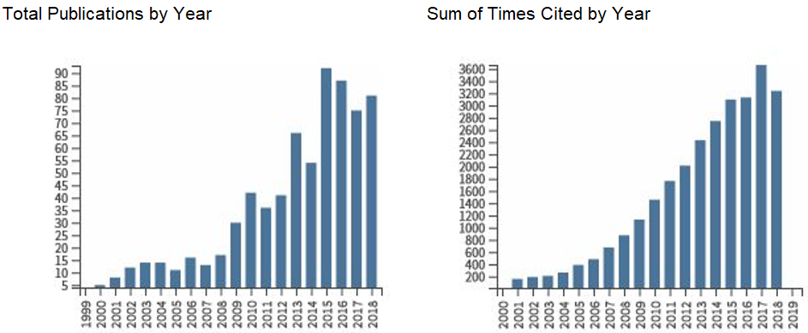

Figure S1. Total publications by year and sum of times cited for the studies captured by our search terms.

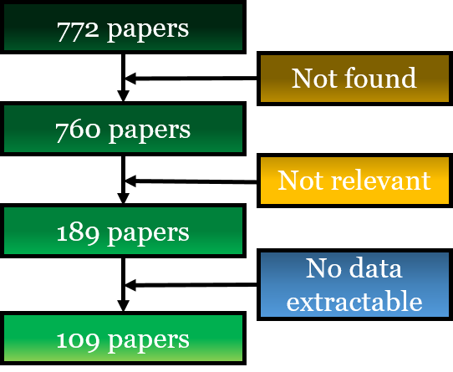

Figure S2. Flow chart of the number of papers screened, and those included and excluded using three filters. This process resulted in 109 relevant papers, which provided information on 132 taxa.

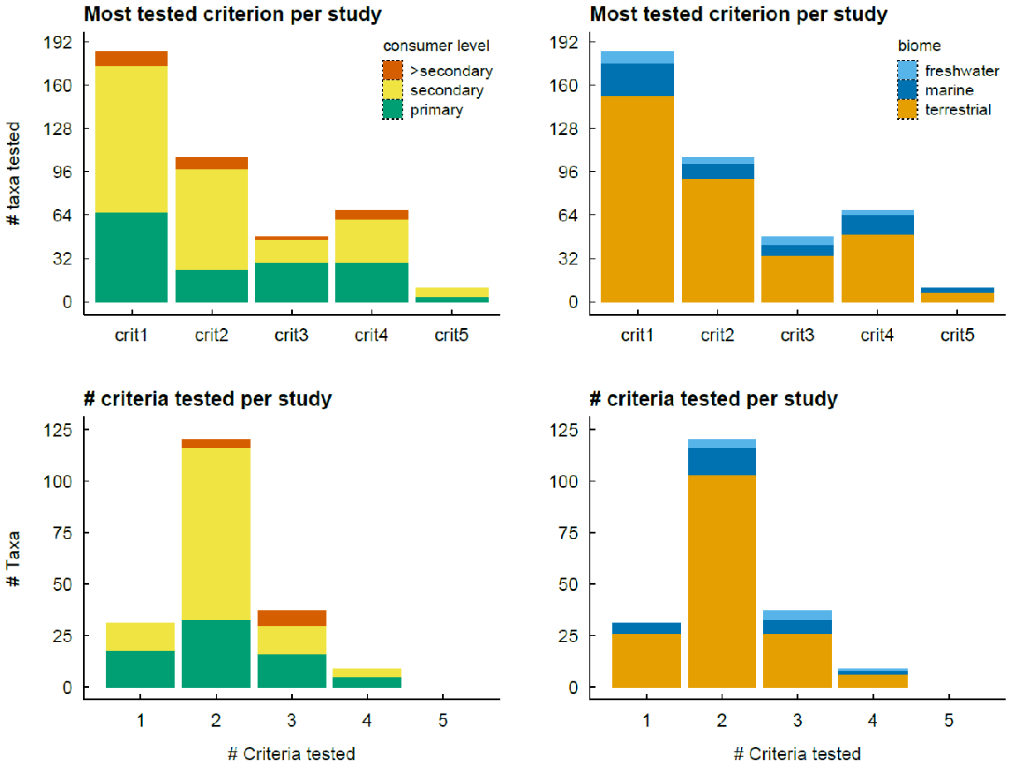

Figure S3. Overview of all the study-by-taxon combinations identified (200 in 109 papers), showing which (and how many) criteria were studied in individual papers.